**Project 1**

**Game Title:**

Poker Card Game

**Project 1 Includes:**

Versions 1,2 & 3 of My Development

**Course:**

CSC 17C Spring 2017

**Section:**

42475

**Date Due:**

April 18, 2018

**By:**

Javier Ventura

**Introduction:**

For Project 1, I was stuck choosing a game at first, considering that all my C++ courses have been under Dr. Lehr. For CSC 5, I chose a Blackjack game and for CSC 17A I did a Snakes and Ladders game. Running these games on console is not the most pleasant visually but they can still be fun and a good challenge to put concepts to the test in a real application. I liked how challenging card games can be and how many options they are so I went with another game I play with family and friends: Poker. I went with a 5 Card Draw Poker with 2 Betting Rounds and up to 3 Card swaps. This was fun to incorporate into a project with tons to still improve on. Maybe even later, I could consider using a 3D/2D rendering engine like Unity or Unreal Engine to build for a more visual project. However, before then I still have some work to do.

**Summary:**

In the project folder I include three versions; in version 1 I try to just get the game running with basic concepts mostly found in CSC 5. In version 2 I then use concepts based off a object-oriented programming style mostly found in CSC 17A. This helped clean up the main and increased the speed of the code running. In version 3 is where I started to add concepts from our current course. This allowed me to compare where new concepts would fit best since code was already written, as opposed to have to write new concepts from scratch. This was better because I could see how lengthy something was and either cut code down or if not write something that more reusable and had performance like maps. Which is what the STL is about, Nicolai Josuttis does a great job explaining the library in his book “The C++ Standard Library”, where I found examples to help with my project. He also praises the library for the same reasons,also warning however, of misusing the library and the problems that can arise. Nonetheless learning about the STL and how to use it properly is definitely a powerful skill to have as a programmer, so as a stepping stone to that, I was excited for this project.

I do use maps for creating decks for the game as well as sets and linked lists to store wins and losses. Shuffling the deck is easier to do with the concepts from the library and outputting cards is also much easier in my way than to use multiple functions that I was using before. My total count of code is 946 but around 50 lines of blank space or only comments is used. I hope to improve the AI of the opponents in the game and the ranking system to be more accurate and faster.

Github Link:

https://github.com/jventura10/Ventura_Javier_CSC17C_Spring2018/tree/master/Project/Project%201

**FlowChart (Main):**

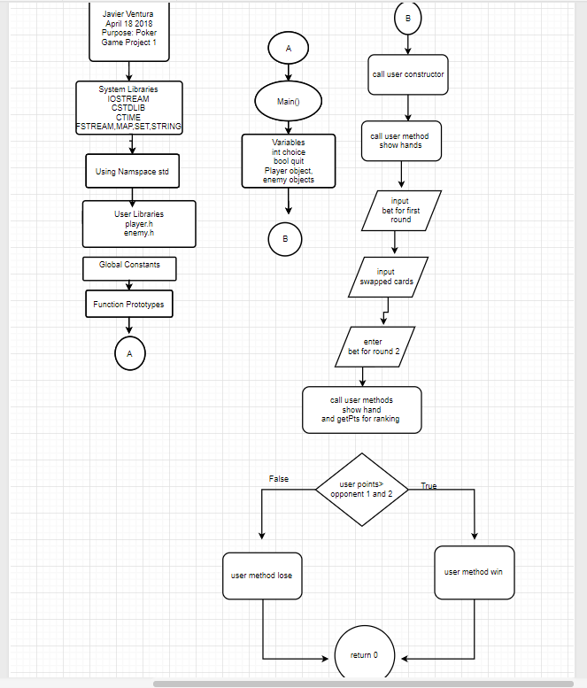

**Source Code (Main):**

**\/\***

**\* File: main.cpp**

**\* Author: Javier Ventura**

**\* Purpose: CSC 17C Project 1 Poker Game Version 3 is Starting to use Object**

**\* Concepts from STL**

**\* Created on April 11, 2018, 3:24 PM**

**\*/**

**//Libraries**

**#include <cstdlib> //C Standard Library**

**#include <iostream> //Input & Output Library**

**#include <ctime> //C Time Library**

**#include <map>**

**#include <set>**

**#include <fstream> //File Stream Library**

**#include <string>**

**//User Libraries**

**#include "enemy.h"**

**#include "player.h" //String Library**

**using namespace std;**

**int main(int argc, char** argv) {**

**//Set Random Number Seed**

**srand(static_cast<unsigned int>(time(0)));**

**//Declare Variables**

**int choice; //Choice from the Menu**

**bool quit=false; //Boolean to keep Menu Running**

**int import; //Import Option to Read in General Poker Rules**

**char opt; //Option to Fold,Match, or Raise**

**Player user; //User Object for PLayer**

**Enemy opp1; //Opponent 1 in the table**

**Enemy opp2; //Opponent 2 in the table**

**do{**

**cout<<"5 Card Draw Poker!"<<endl;**

**cout<<"------------------"<<endl;**

**cout<<"(1) Play Game"<<endl;**

**cout<<"(2) Basic Rules"<<endl;**

**cout<<"(3) Beginner's Guide To Poker"<<endl;**

**cout<<"(4) Poker Hands Ranking"<<endl;**

**cout<<"(5) Add Bitcoin to your Betting Pot"<<endl;**

**cout<<"(6) Change Username"<<endl;**

**cout<<"(7) Quit Game"<<endl;**

**cout<<endl;**

**cout<<"Enter Option: ";**

**cin>>choice;**

**while(choice<1 || choice>7){**

**cout<<endl;**

**cout<<"Enter Valid Option: ";**

**cin>>choice;**

**}**

**switch(choice){**

**case 1:{**

**cout<<endl;**

**user.showCards();**

**user.setbet1();**

**if(user.getbet1()<=0){**

**break;**

**}**

**user.swap();**

**user.showCards();**

**user.setbet2();**

**if(user.getbet2()<=0){**

**break;**

**}**

**user.setPts();**

**opp1.setPts();**

**opp2.setPts();**

**if(user.getPts()>opp1.getPts() && user.getPts()>opp2.getPts()){**

**cout<<endl;**

**cout<<"You Won!"<<endl;**

**user.win();**

**cout<<endl;**

**}**

**else{**

**cout<<endl;**

**cout<<"You Lost!"<<endl;**

**user.lose();**

**cout<<endl;**

**}**

**cout<<endl;**

**break;**

**}**

**case 2:{**

**cout<<endl;**

**cout<<"Rules of the Game (5 Card Draw Poker):"<<endl;**

**cout<<"Each player will receive 5 (hole) cards"<<endl;**

**cout << "T =Ten Q=Queen J=Jack K=King A=Ace S=Spades C=Clubs D=Diamonds H=Hearts";**

**cout<<"Each player may fold, raise the bet or match the bet"<<endl;**

**cout<<"Each player may ask for up to three changes in cards"<<endl;**

**cout<<"Another betting round will occur"<<endl;**

**cout<<"There is no limit to betting, as long as you have the bet in your pot"<<endl;**

**cout<<"New Players are given 2 Bitcoin to start off"<<endl;**

**cout<<"Winner is based on Poker Hands (See Option 4)"<<endl;**

**cout<<"***Complete Poker Guide See option 3***"<<endl;**

**cout<<endl;**

**break;**

**}**

**case 3:{**

**cout<<endl;**

**cout<<"Beginner's Guide to Poker: "<<endl;**

**cout<<"--References--"<<endl;**

**cout<<"https://www.bicyclecards.com/how-to-play/basics-of-poker/"<<endl;**

**cout<<"https://www.pokerlistings.com/poker-rules-5-card-draw0"<<endl;**

**cout<<endl;**

**cout<<"Enter 1 to import general rules or 2 to return to Menu: ";**

**cin>>import;**

**if(import==1){**

**cout<<endl;**

**ifstream file("guide.txt");**

**string line;**

**while(getline(file,line)){**

**cout<<line<<endl;**

**}**

**file.close();**

**}**

**else{**

**cout<<endl;**

**break;**

**}**

**cout<<endl;**

**break;**

**}**

**case 4:{**

**cout<<endl;**

**cout<<"Poker Hands Ranking: "<<endl;**

**cout<<"H-Hearts S-Spades C-Clubs D-Diamonds"<<endl;**

**cout<<"Royal Flush: 10-H J-H Q-H K-H A-H"<<endl;**

**cout<<"Straight Flush: 3-S 4-S 5-S 6-S 7-S"<<endl;**

**cout<<"Four of a Kind: 10-S 10-C 10-D 10-H 5-D"<<endl;**

**cout<<"Full House: J-H J-C 7-D 7-H 7-C"<<endl;**

**cout<<"Flush: 2-H 6-H 9-H J-H K-H"<<endl;**

**cout<<"Straight: 3-H 4-C 5-D 6-C 7-S"<<endl;**

**cout<<"Three of a Kind: "<<endl;**

**cout<<"Two Pairs: "<<endl;**

**cout<<"1 Pair: "<<endl;**

**cout<<"No Pair/High Card: "<<endl;**

**cout<<endl;**

**break;**

**}**

**case 5:{**

**cout<<endl;**

**user.addCoin();**

**cout<<endl;**

**break;**

**}**

**case 6:{**

**user.setName();**

**}**

**case 7:{**

**cout<<endl;**

**cout<<"Quitting Game... :("<<endl;**

**return 0;**

**}**

**default:{**

**cout<<endl;**

**cout<<"Enter Valid Option!"<<endl;**

**cout<<endl;**

**}**

**}**

**}while(quit==false);**

**//Exit**

**return 0;**

**}**